**CSC 1100 – Problem Solving and Programming**

**Homework 1 – Trevor Trusty**

**25 points – Due January 17, 11am**

**1) [4 points]** Using information from the Internet or a textbook, list four trends in the future of computing. Include your sources in the form of hyperlinks or book citations.

| # | Trend | Source |
| --- | --- | --- |
| 1 | Larger scale implementation of conversational/voice Artificial Intelligence for tasks at home, work, etc. | https://www.forbes.com/sites/forbestechcouncil/2016/12/27/upcoming-technology-10-trends-to-watch-in-the-next-five-years/#7ec27eab2fd1 |
| 2 | Because of all of the services most of us use that contribute to machine learning, by 2020 AI will no longer need us to “aid its learning” | https://appinventiv.com/blog/10-tech-trends-that-will-become-mainstream-by-2020 |
| 3 | The 5th gen. of cellular network technology will appear by 2020 with improvements over today’s 4g connection, such as the latency and speed. | https://appinventiv.com/blog/10-tech-trends-that-will-become-mainstream-by-2020 |
| 4 | WEB 3.0, technology where our data would be directly readable by the computer. | https://hackernoon.com/future-technology-trends-that-gonna-rule-the-planet-fa2f578f22eb |

**2) [5 points]** Using information from a smartphone vendor (like Apple, Samsung, LG, ZTE, etc.), choose one of their products and list specifications for the following features.

Source (hyperlink): https://www.samsung.com/us/mobile/phones/galaxy-note/galaxy-note9-128gb--unlocked--sm-n960uzkaxaa/

Vendor: Samsung_______________

Product: Galaxy Note9 128GB (Unlocked)_______________

| Feature | Specification |
| --- | --- |
| CPU | 2.8 GHz,1.7 GHz |
| Memory size | 6GB RAM |
| Storage medium and size | 128GB (ROM), and microSD support up to 512GB |
| Operating system | Android 8.1 |
| Price | $999.99 |

**3) [10 points]** Convert the following numbers. Show your work for each conversion.



a) Binary 1011 to decimal



b) Binary 110001 to decimal

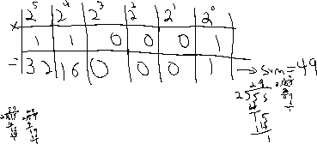

c) Decimal 55 to binary

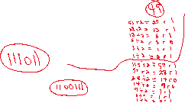

d) Decimal 115 to binary

**4) [4 points]** Using the UNICODE charts available at [unicode-table.com/en/](http://unicode-table.com/en/),

list the characters and corresponding UNICODE numbers of the name of your favorite town or city. List one character and UNICODE number per row in the following table.

| # | Character | UNICODE number (U+HHHH) |
| --- | --- | --- |
| 1 | **C** | U+0043 |
| 2 | **H** | U+0068 |
| 3 | **I** | U+0069 |
| 4 | **C** | U+0063 |
| 5 | **A** | U+0061 |
| 6 | **G** | U+0067 |
| 7 | **O** | U+006F |

**5) [2 points]** How many bits would you need to represent 32 different values?

Show your calculation.



Bits: ____5___________

